|  |  |  |  |  |  |
| --- | --- | --- | --- | --- | --- |
| Date | 7-Dec-22 | | | Tester Name | Select Name |
| Environment | Penfax - Test 2 | | | Login used | <If different from the Tester> |
| Operating System | Windows | Version: | Update Number: | | |
| Software Used | Select Software | Version: | Update Number: | | |
| Select Software | Version: | Update Number: | | |
| Application Release version | R22.4.1 | | | | |
| Test Case Title | YearEnd catch up payment | | | | |
| Test Type | Regression | | | | |
| Test Scenario | E23.18 | | | | |
| Expected Results | Yearend catch up payment should be included in the December VPB Scheduled payment run | | | | |
| Pass/Fail | Select | | | JIRA# | <enter the new JIRA ticket number if the test case failed> |

Notes: The VPB yearend catch-up payments are included in the December VPB Scheduled Payments job.

* Prior to executing starting your test cases you will need to run a before query. The BI team can do this for you. The query is called “**Catch Up Payment Min Withdrawal for Age 72**”

In test, if you’re running the December VPB scheduled payment outside 3 business days from Dec 31st, you will need to change the Plan Parameters in the Plan Rules to reflect the number of business days where you would like PIT to w/d funds from member’s account.

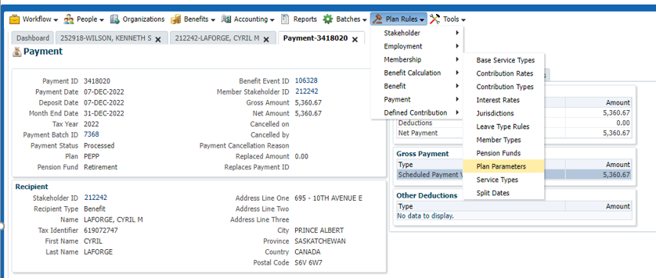

In Plan Parameters, select PEPP Plan, then click on DC Administration>Investment Management>Scheduled W/D Business Day before End of Month

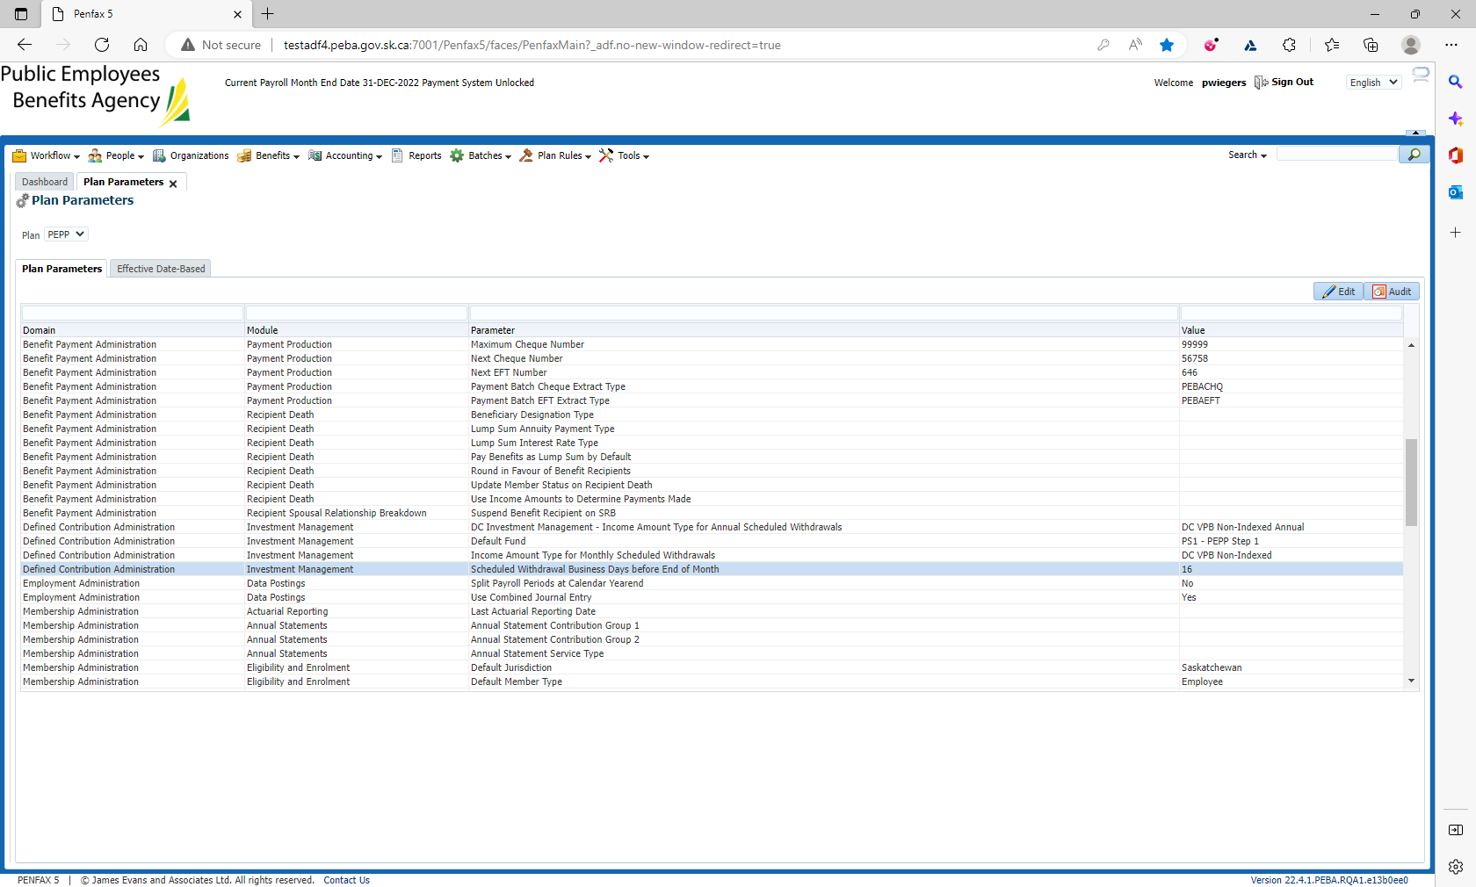

Change the value in the Value column from 3 business days (Production value) to the number of business days you want PIT Batch to w/d funds from members account. In this test scenario we’re going to change it to 16 business days. Then save change.

In the nightly batch cycle, PIT batch will process a w/d from member’s account based on their scheduled payment instruction and any catch up amount if required.

The follow day after PIT batch have processed the w/d, we need to run a Payment Production job.

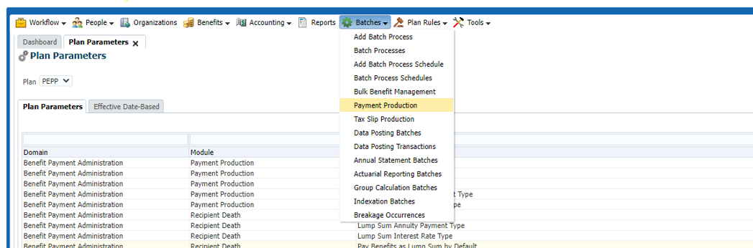

Click on Batches>Payment Production

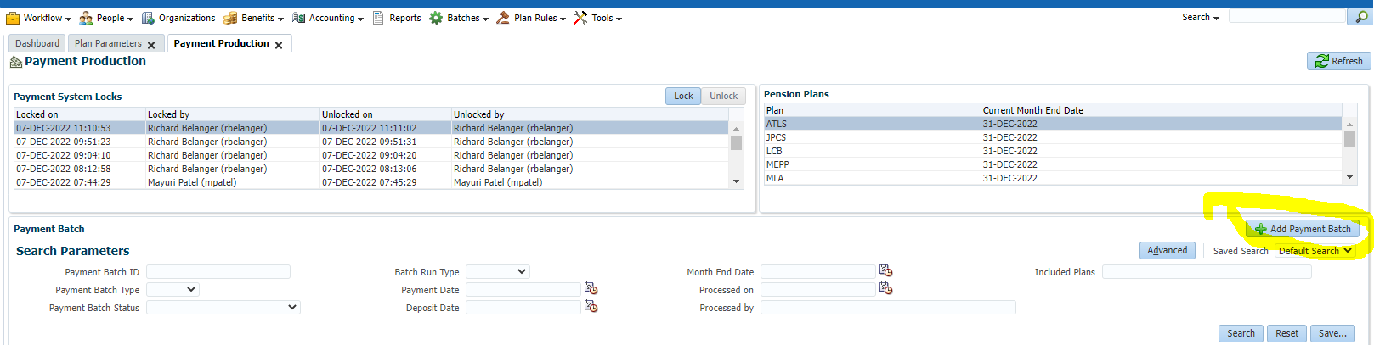  
Click on Add Payment Batch, then fill in the required information.

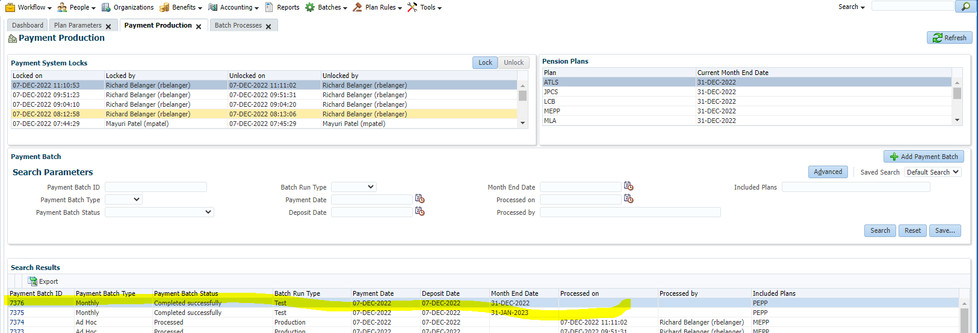

System will show when the job is completed.